COURSE CODE: PRAC101 Section: BSIT - 4113

COURSE TITLE: OJT / PRACTICUM 1

TERM: 1st Semester, SY 2024-2025

PROFESSOR: MR. VINCENT CARLO T. GARADOS

NAME OF STUDENT: FAGUTAO, JOHN LESTER C.

**OJT NARRATIVE REPORT**

1. TOPIC: FAMILIARIZING WITH AI  
   Session 4 : Workshop
2. SPEAKER: MR. MARC TONIDO
3. DURATION: 3:45 PM – 5:00 PM
4. SCREENSHOT OF DUTY

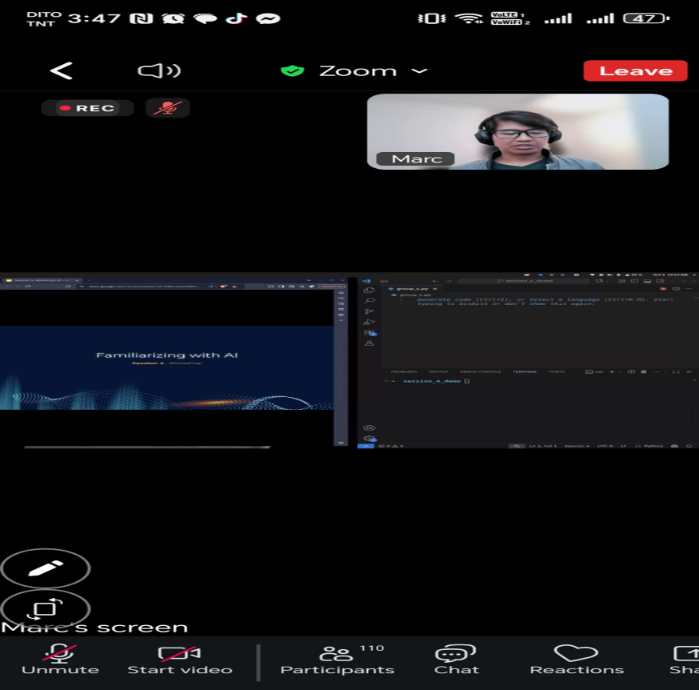

1. REFLECTION

In Session 4, which focused on a Workshop about Sentiment Analysis using Python, I learned how AI can understand human emotions through text. The goal of the activity was to create a script that detects whether a given phrase or sentence expresses a positive or negative sentiment. This helped me realize how AI systems can interpret opinions and feelings in data such as reviews or social media posts.

We used several Python libraries for this workshop, including nltk (Natural Language Toolkit), pandas, and SentimentIntensityAnalyzer from VADER. I discovered that the VADER Lexicon is a very useful resource because it already contains a dictionary of words and symbols that have pre-assigned sentiment scores ranging from -4 (most negative) to +4 (most positive). This made it easier to analyze text without manually labeling data.

Through the sample analysis, I understood how the SentimentIntensityAnalyzer works by assigning scores to each word and calculating an overall sentiment rating for a sentence. The results show whether the tone of a message is positive, negative, or neutral.

Finally, the interactive part of the workshop allowed users to type their own phrases and instantly get the sentiment result. I found this very interesting because it demonstrated how simple scripts can make AI more interactive and practical.

Overall, this workshop helped me appreciate the real-world application of AI in analyzing emotions and opinions. It gave me hands-on experience in using Python libraries and made me more confident in exploring Natural Language Processing (NLP) projects in the future.